**RWZ Notes**

sub_7FF7C37F7474: contains identifiers

sub_7FF7C3810F00: contains identifiers

dd 0ECD76h, 0ED03Ch, 0EF5BDh, 0F4240h, 10C8E0h, 124F80h

.rdata:00007FF7C40CDA58 ; DATA XREF: sub_7FF7C26D8D94+4A1A8B↑o

.rdata:00007FF7C40CDA58 ; sub_7FF7C37A1A90+289↑o ...

.rdata:00007FF7C40CDA58 dd 140000h, 150000h, 2 dup(0)

**CRuleElement mentions**

sub_7FF7C28FF0D0

RuleElementClassName

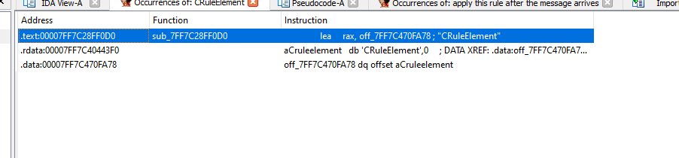

**Rulewiz.dll**

[**https://www.computerhope.com/download/updates.htm**](https://www.computerhope.com/download/updates.htm)